Enterprise System Development Report
“The Cat Whiskers Hotel”

Full name: Arain Ahmed
Student Number: 1802877

A final report submitted in partial fulfilment of the requirements for the degree BSc Computing at the University of Bolton.

Course: Computing (Top-up Year)

Date: 04/02/2020

Tutor: Andrew Holland

Contents
List of Figures 3
1. Introduction 4
2. Stage 1: Clients and Business Requirements 5
2.1 Project Plan 5
3. Stage 2: Technical Requirements and Design 8
3.1 The main enterprise management application 8
3.2 A simple mobile device application 14
3.3 A simple web service for use by the CCTV mobile phone app 15
4. Stage 3: Build of applications 16
4.1 The main enterprise management application 16
4.1.1 Outline steps and Screenshot Evidence 16
4.1.2 Issues encountered and solutions during development 21
4.2 A simple mobile device application and web service CCTV 24
5. Stage 4: Creation of documentation and testing 24
User Guide 24
6. Evaluation 30
7. Conclusion 31
References 31

List of Figures
Figure 1: Screenshot of Excel Tables 8
Figure 2: ERD Diagram of Table of Fields 11
Figure 3: Screenshot Taken From Visual Studios Showing The Code From The Main Application 13
Figure 4: A Migration being added to the system 17
Figure 5: Adding a new class to the system 17
Figure 6: Naming the class and choosing the correct one 18
Figure 7: Adding a controller to the system 18
Figure 8: Choosing the type of controller 19
Figure 9: Naming the controller and choosing the correct model to go with it 19
Figure 10: The cats page is being shown in MIcrosoft Edge 20
Figure 11: The Cats Controller is being shown which shows the data types 20
Figure 12: An error message popped up saying the database has changed and needs the migration to be updated 21
Figure 13: Data inputted for Owner 22
Figure 14: The data has disappeared despite the create button being pressed 23
Figure 15: Warning messages to let the user know to put numbers in instead of letters 23
Figure 16: Despite the warning about numbers, the system allowed data to come through despite limitations being placed beforehand 24
Figure 17: Visual Studios opened but not the solution 25
Figure 18: The solution is opened and can now be accessed through Microsoft Edge 25
Figure 19: The homepage that appears when the application runs on Microsoft Edge 26
Figure 20: The Cats page is opened 26
Figure 21: The Create new page for Cats but no information has been placed inside yet 27
Figure 22: The Create New page for Cats with data placed inside 27
Figure 23: The Data is now showing on the Cats Page 28

Introduction
The following report is to present the process of developing an application that will be used to store customers data and will be used by the owners of The Cat Whiskers Hotel. This report will show the steps taken to develop several deliverables, these include the main enterprise application, the secondary mobile phone and the web service application. The first step that was taken was identifying and appraising the role of both patterns and frameworks. This was in order to investigate how frameworks were suitable for the task at hand; a huge amount of research was undertaken in order to understand frameworks and how they are used. Patterns are used while developing the code and can make the program easier for the user to understand. The second step that was taken was to analyse, select and synthesize technologies that use the required framework. These technologies were analysed by breaking them down into their essential features and to examine them in detail. The third step that was taken was to examine the relationship between business goals and software development. This was necessary in order to ensure the clients requirements were included in the software. The forth step that was taken was to research and implement a number of software elements in order to meet the business/ infrastructure needs in a secure manner. This research was vital as application security is important in order to ensure the client’s system are not vulnerable to hackers. The fifth and final step taken was to plan, construct and demonstrate the enterprise application. This was essential as the client needed to see a prototype build in order to ensure that the application matched their requirements.

Stage 1: Clients and Business Requirements

2.1 Project Plan
Project Title: | Start Date | End Date | Progress to date /Evidence of Achievement
The Cat Whiskers Hotel | 15/10/2019 | 27/03/2020
Milestones:
Any questions you need to ask Joe Felix for clarity on what is required should be asked during your initial meeting with him on this date. | 15/10/2019 | 15/10/2019 | The client Joe Felix was asked numerous questions. The questions that were asked were helpful and provided an insight into how to start the project and identify the client’s requirements.
Initial database conceptual schema design should be completed by now “on paper”. | 16/10/2019 | 29/10/2019 | This part was not completed on paper, it was developed on Microsoft Excel and was customisable for the project at hand.
Decision over MVC/MVVM frameworks and languages to be used for main application development should have been made and communicated to your lecturer for verification and agreement. | 30/10/2019 | 05/11/2019 | MVC was chosen for the main application development. This was chosen because there were lessons online which gave the development support by providing the tools and code that were needed for the project.
Decision over mobile application framework/technology/language to be used should have been made and communicated to your lecturer for verification and agreement. | 06/11/2019 | 26/11/2019 | The Framework, technology and language that was to be used to develop the mobile application was JavaScript. This was chosen because a large number of devices support this framework.
“Bones” of a basic working management meeting at least some of the requirements application should exist by this point | 27/11/2019 | 17/12/2019 | The key elements of the main application existed and some requirements were still needed.
Mobile app and web service development should be well under way or even completed. Main application should be near or at completion. Documentation should be near completion. | 18/12/2019 | 07/01/2020 | Mobile application and web service did not enter development due to time constraints.  Main application was in development but could not implement missing features.  Documentation of the whole development was written up.
Tasks:
Complete Project Plan
Agreed Technical Requirements | 15/10/2019 | 17/11/2019 | Completed tables and data and chose the specified program.
Build/Test Main Application | 20/11/2019 | 10/02/2020 | Main application was built; however, some features were missing that the client required. The testing showed that the application functioned but needed more development.
Build/Test Mobile Application and CCTV Application | N/A | N/A | Mobile application was not built due to time constraints.
Demonstration of applications to Joe Felix | 10/02/2020 | 10/02/2020 | Presented Joe Felix with the application. However, he was disappointed as there were mandatory features missing.
Evaluate Application after Demonstration and make changes as necessary | 18/11/2020 | 27/03/2020 | Evaluated the application as there were numerous issues, the changes that were made included coding, design and additional features.
Agree to Maintain Application | 10/02/2020 | 10/02/2020 | Agreed to maintain the application and applied changes where necessary.
Client Follow Up | 27/03/2020 | 27/03/2020 | Obtained feedback from client regarding the application.
Table 1: Project Plan

Stage 2: Technical Requirements and Design

3.1 The main enterprise management application
There were three main stages in order to develop the main application.
- Used excel to create the tables and specified which data fields would be in the application
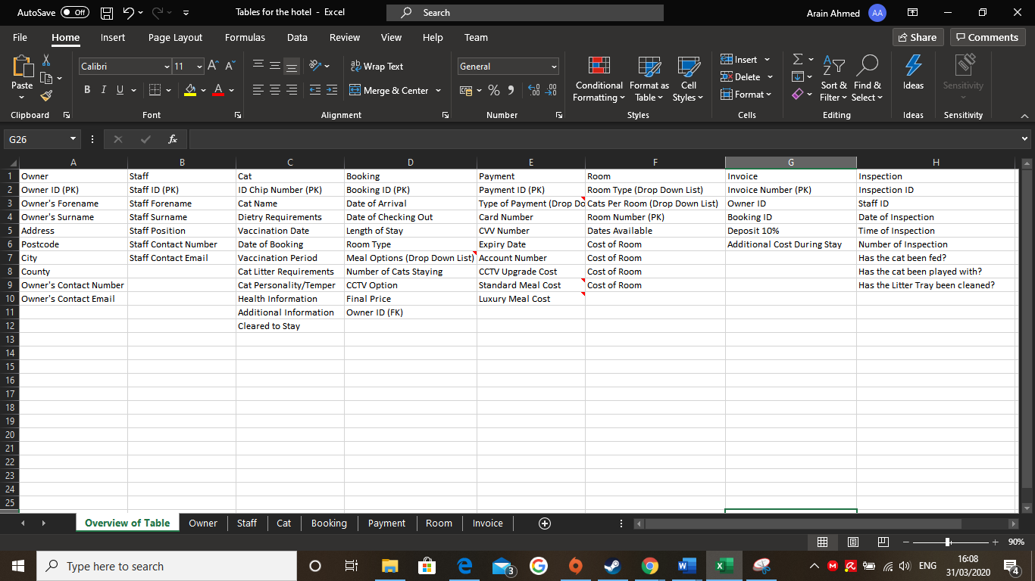
Figure 1: Screenshot of Excel Tables
The screenshot above shows the tables and their data fields, it also shows the primary and foreign keys and the features available in the finished program. The table below illustrates the content of the screenshot. Due to the screenshot being unclear

Table 2: Table of Fields Used in the Application
Owner | Staff | Cat | Booking | Payment | Room | Invoice | Inspection
Owner ID (PK) | Staff ID (PK) | ID Chip Number (PK) | Booking ID (PK) | Payment ID (PK) | Room Type | Invoice ID | Inspection ID
Owner’s Forename | Staff Forename | Cat Name | Date of Arrival | Type of Payment | Cats Per Room | Owner ID | Staff ID
Owner’s Surname | Staff Surname | Dietary Requirements | Date of Checking Out | Card Number | Room Number | Booking ID | Date of Inspection
Address | Staff Position | Vaccination Date | Length of Stay | CVV Number | Dates Available | Deposit 10% | Time of Inspection
Postcode | Staff Contact Number | Date of Booking | Room Type | Expiry Date | Cost of Room | Additional Cost During Stay | Number of Inspection
City | Staff Contact Email | Vaccination Period | Meal Options (Drop Down List) | Account Number |  |  | Has the cat been fed?
County |  | Cat Litter Requirements | Number of Cats Staying | CCTV Upgrade Cost |  |  | Has the cat been played with?
Owner’s Contact Number |  | Cat Person | CCTV Option | Standard Meal Cost |  |  | Has the Litter Tray been cleaned?
Owner’s Contact Email |  |  | Final Price | Luxury Meal Cost
 |  |  | Owner ID (FK)

- The next stage was to use software that specialised in ERD (Entity Relationship Diagram) diagrams. ERD is representative of an entity framework, it illustrates what the database will look like as it is used for database object relationship mapping, however it will not state how to implement it. In order to show the relationships between the tables. This is useful because it shows that the tables are connected in order to extract information between each other.

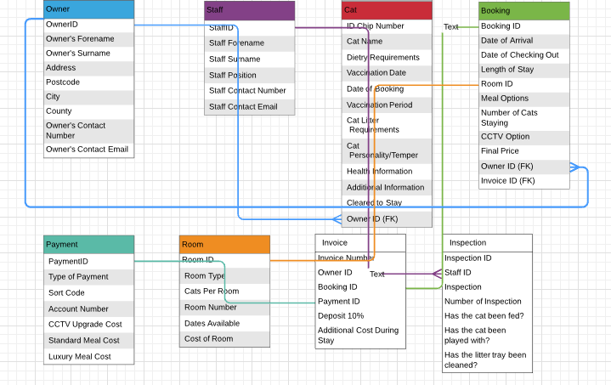
Figure 2: ERD Diagram of Table of Fields
Figure 2 Shows the relationships between each table and how they are connected to each other with the primary and foreign keys.

- The final stage was to use Visual Studios to develop the program by using the MVC (Model-View Controller) framework, to create the application architecture.

Prior to this final stage the MVC design pattern was compared against other popular design patterns including MVP (Model View Presenter) and MVVM (Model View View-Model). Overall, these patterns develop applications which are easy to test and maintain and quite flexible. All the patterns can work within the Android platform.

Analysis of three design patterns (Sinhal, 2017)
Table 3: Design Patterns Comparisons
 | MVC | MVP | MVVM
Android Platform |  |  | 
Model | Model holds the data and then transfers it to View in order to be displayed to the user. | The model uses business logic and data. It states how data can be altered and used. | -
View | View displays the data e.g. HTML and XML. Interaction between Model and View is undertaken by using an observer pattern. | View displays the data without implementing logic. | -
Controller | The controller manages the model data flow between the model and the view. | - | -
Presenter |  | View sends the data to the presenter via an interface. Together with model, presenter processes the data and sends it back to view. Presenter manages the model and updates view. | -
View Model |  |  | It has many uses exposing methods, commands, properties and it maintains its view state and manages the model. Many views can be mapped to View Model and is quite different from views that are found in MVP and MVC.
Additional Features | MVC was compatible with Visual Studios | It’s easier to test applications using MVP design pattern compared to the MVC design pattern | MVVM design pattern supports bi-directional data binding.

Analysis of Enterprise Development Frameworks (InfoTech, 2019)
Table 4: Enterprise Frameworks Comparisons
Project Requirements | .NET Core | .NET Framework
Application/Mobile/Web CCTV Service | Has cross platform needs | -
 | This framework is supported for visual studios | This framework is supported in visual studios
 | - | Has access to third party .NET libraries and NuGet packages not seen in .NET Core

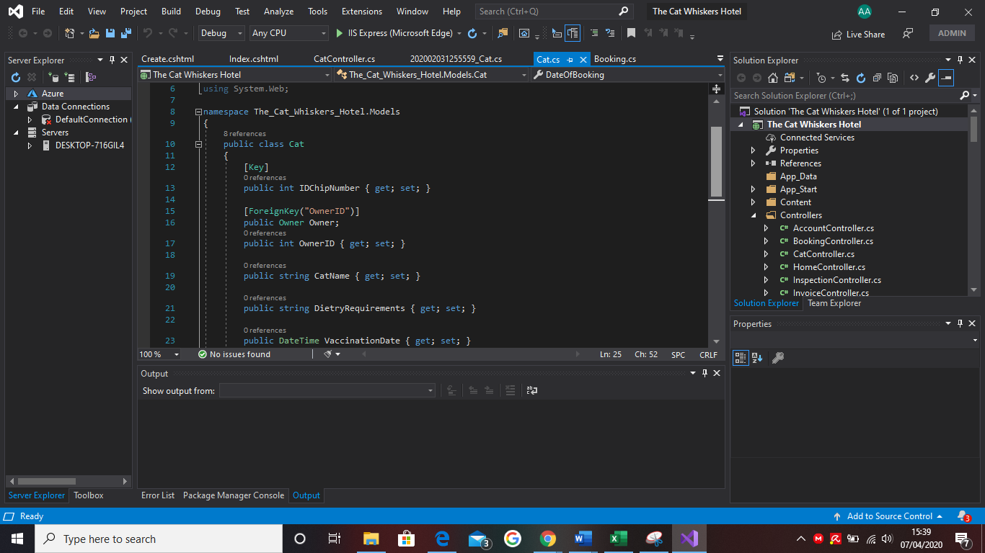
Figure 3: Screenshot Taken From Visual Studios Showing The Code From The Main Application
Figure 3 Shows the code for one of the controllers. In this case, the controller illustrates the code to mobilise the fields and data types which will then appear when the application is running in an internet browser. The controller that is being shown above is the “Cats Controller” which displays the primary key and foreign key along with other required data fields. The language that was used to build the application was C#, this was used because it was simple and the framework’s program supported this language.

In addition, consideration was given to potential security threats due to the system being available over the internet. The common security threats for a enterprise system are phishing, malware and hacking into accounts with weak passwords. The best way to overcome these threats is to make users provide a strong password as weak passwords are easy to access, a strong password would need to contain a higher-case letter, a lower-case letter, a number, a symbol and a certain length in order to protect an account. Another way to overcome these threats is to not access phishing emails while at work, these can look real but they can be distinguished from an authentic email by spelling errors, poor grammar and poor punctuation, if the email does indeed look authentic, it may be best to access the email at home or over a VPN (Virtual Private Network) where they cannot access confidential information. The last way to overcome these threats is to download an anti-malware software in order to defend against attackers. This is an important process as companies in the past have been infected with ransomware, due to poor system security, and resulting in failure to stop the attack. As a consequence, malware has infected thousands of computers and stolen personal accounts and information.

3.2 A simple mobile device application
- Mobile application
The client wanted a mobile application that showed key information about the cats staying at the hotel, this was to be used by the staff who visited the cats in order to determine the best approach to care for the cats.
- Justify the choice of the mobile technology
The program of choice was visual studios in order to develop the mobile application so that it was compatible with the main application which was also being developed in visual studios, therefore it would be easier to merge the two together. Android studio was considered a possibility, however it was rejected because it would have been too complicated to merge the two applications together.
- Potential difficulties and possible solutions
The main anticipated difficulties were potentially connecting the mobile application to the main application due to a lack of software compatibility which could cause the system to crash the program. Another difficulty that could occur during development would be the coding language used which could cause technical errors that renders the program, unusable. The best way to overcome this problem is to maintain a back-up copy of the application, therefore, if an error occurs, the back-up copy would be used in order to locate the difference in the code that was fully functioning before the error occurred. However, this would be hard to predict as entering the same code again may not cause the error but highlights another problem. The last potential difficulty anticipated is to make sure the application supports all mobile devices used by the hotel, because the application will be built using the Android SDK framework which would only support Android devices. The solution to this problem would be to ask the client if he wants to make this app available for iOS devices as everyone has different phones.

3.3 A simple web service for use by the CCTV mobile phone app
1. Mobile application
The client wants to have a mobile application which allows guests to see their cats through a camera via CCTV. However, the client also wants the camera to be seen on certain days which means that there will be restrictions as to when the owners will see their cats.
2. Justify the choice of mobile web service application
The program of choice was visual studios in order to develop the CCTV mobile application because the other applications were made using this program which also supports JSON (JavaScript Object Notation). Android studio was considered a possibility, however it was rejected because it would have been time-consuming learning a new program.
3 Potential difficulties and possible solutions
The main anticipated difficulties were not having enough knowledge on how to utilise JSON (JavaScript Object Notation). The solution to this issue would be to learn the language in order to see how it has been utilised to build similar programs. Another anticipated difficulty would be choosing the best CCTV web service mobile application for the CCTV system in the hotel. A solution to this is to do further research.

Stage 3: Build of applications

4.1 The main enterprise management application
Following the identification of the technical requirements and designing the main tables, the next stage was to build the application to the client’s specification. The following outlines the main steps

4.1.1 Outline steps and Screenshot Evidence
Step 1: Choose the MVC (Model-View Controller) framework
Step 2: Create the Migrations for the Model and Controllers
Step 3: Create the Models
Step 4: Create the Controllers
Step 5: Open up in Internet Explorer to see if application runs without issues
Step 6: Add Data Fields and Data Types to the Controllers
Step 7: Repeat Step 5
Step 8: Go into the Design Code and add changes to the main application such as adding a custom image or making the page look realistic
Step 9: Add a log in page for the staff to access the data
Step 10: Add options to save a booking and make it appear across the whole database with primary and foreign keys

Screenshot Evidence:
Step 2
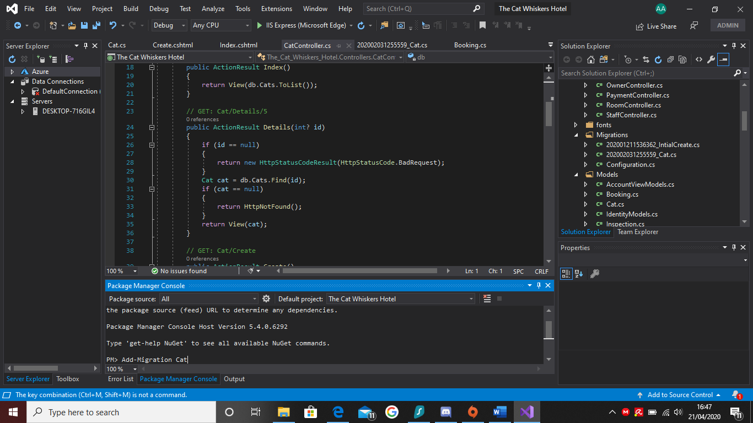
Figure 4: A Migration being added to the system
Step 3
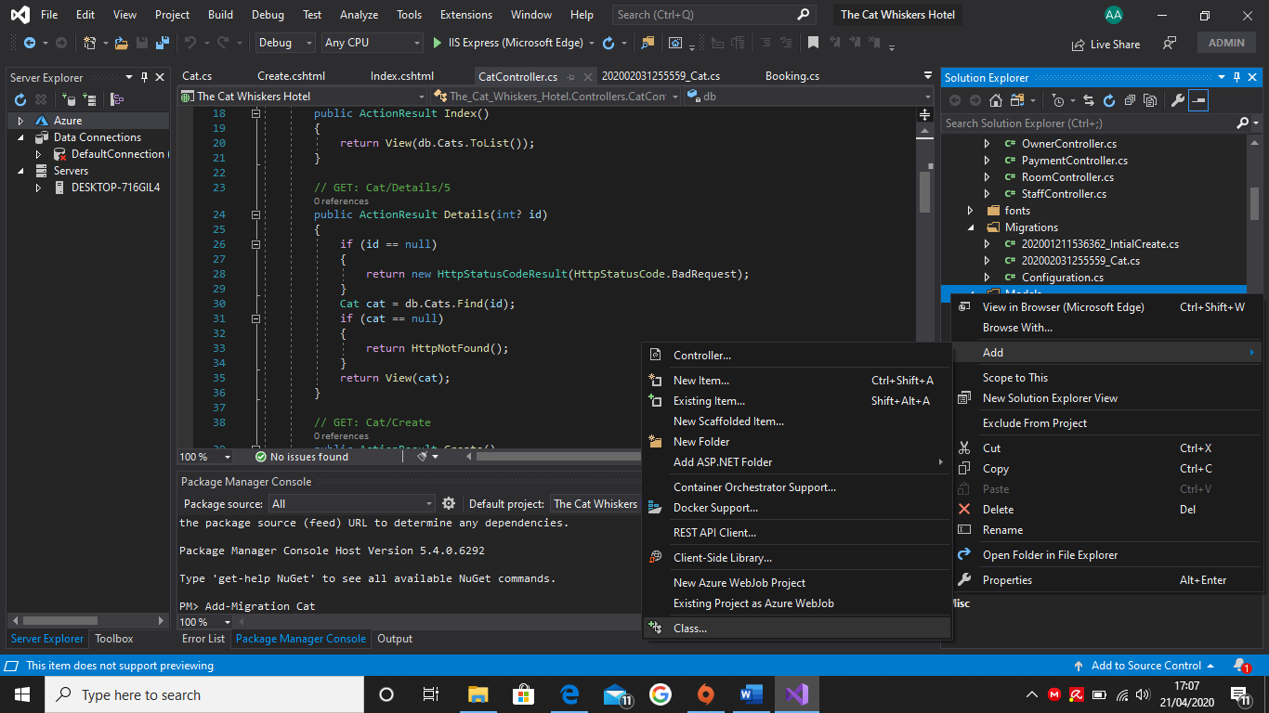
Figure 5: Adding a new class to the system
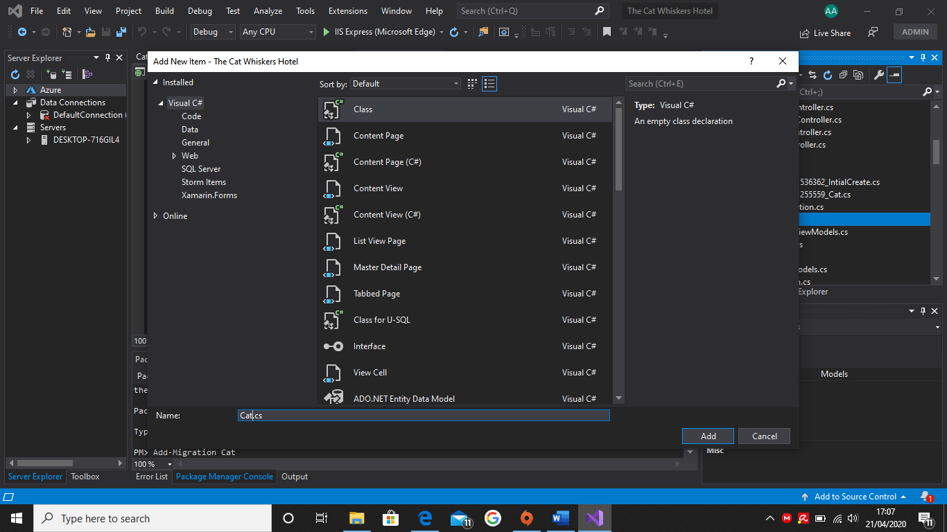
Figure 6: Naming the class and choosing the correct one
Step 4
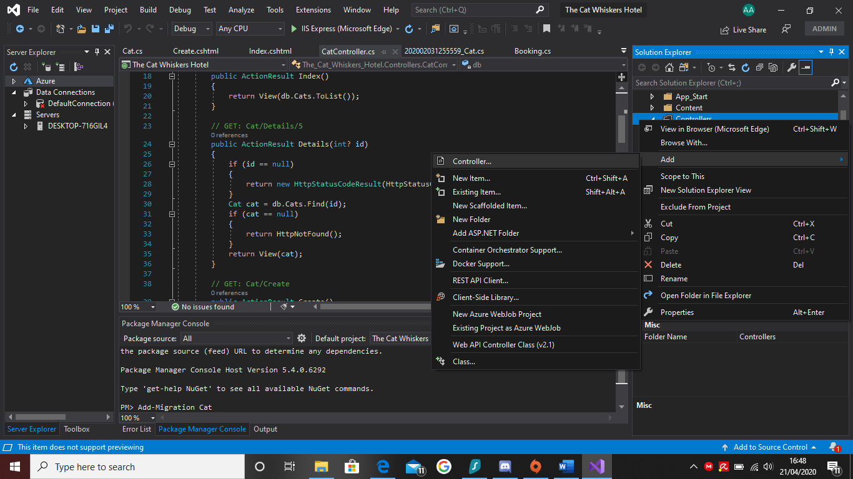
Figure 7: Adding a controller to the system
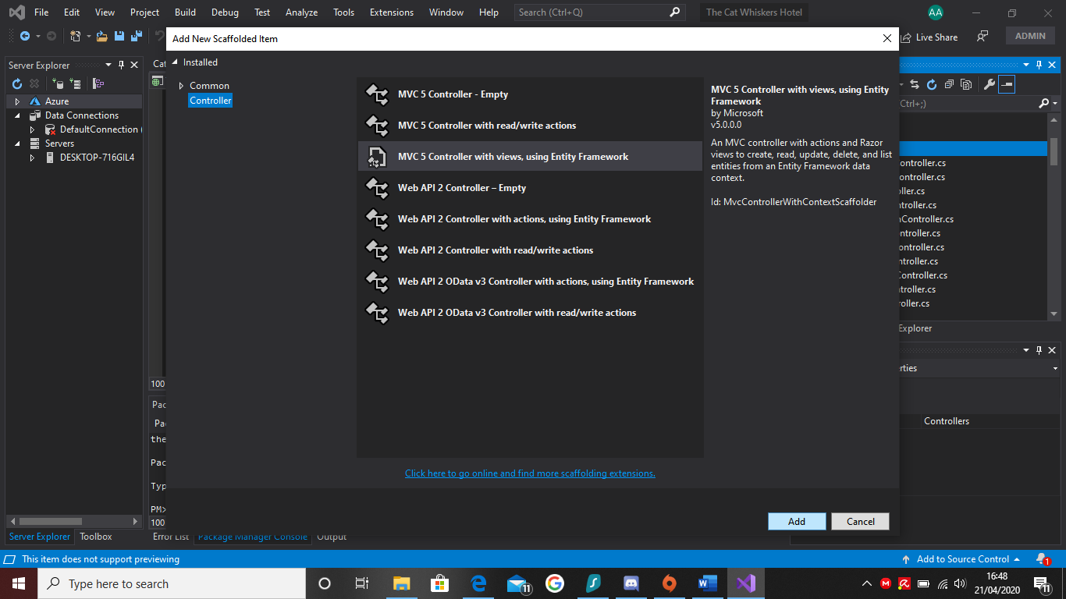
Figure 8: Choosing the type of controller

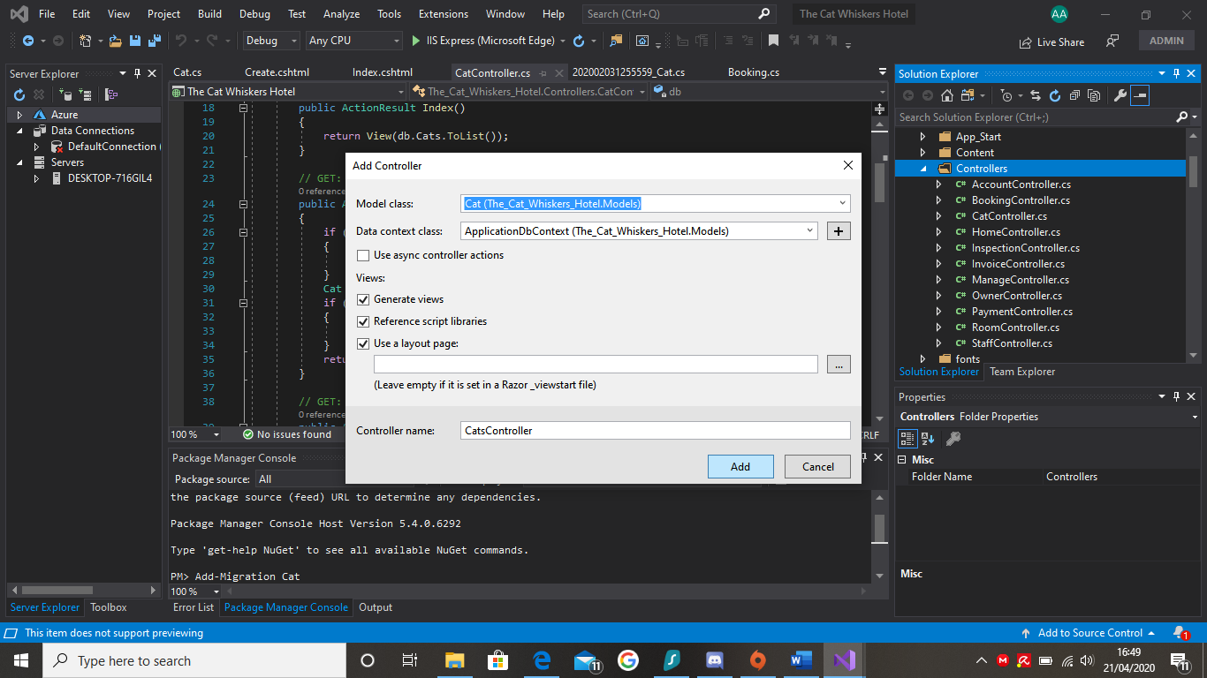
Figure 9: Naming the controller and choosing the correct model to go with it

Step 5
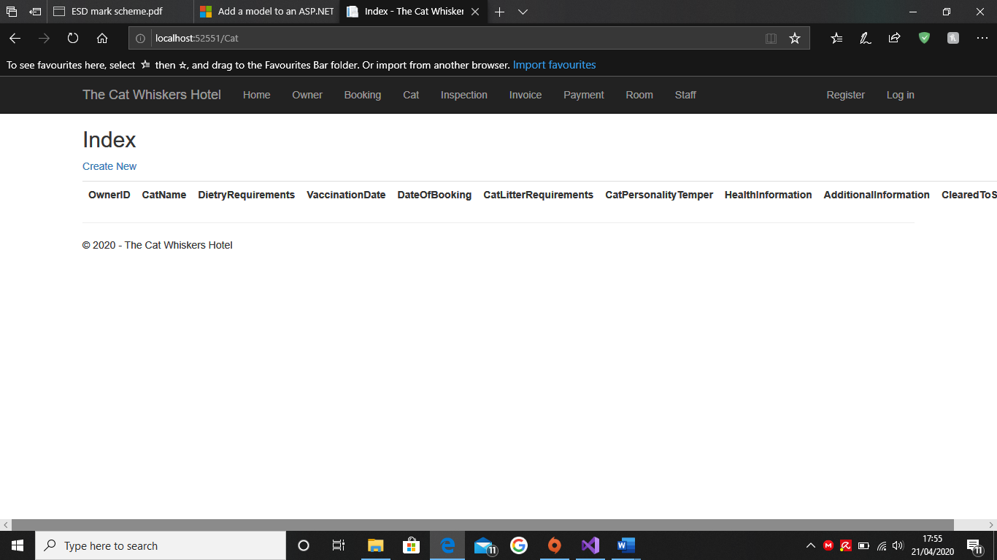
Figure 10: The cats page is being shown in MIcrosoft Edge

Step 6
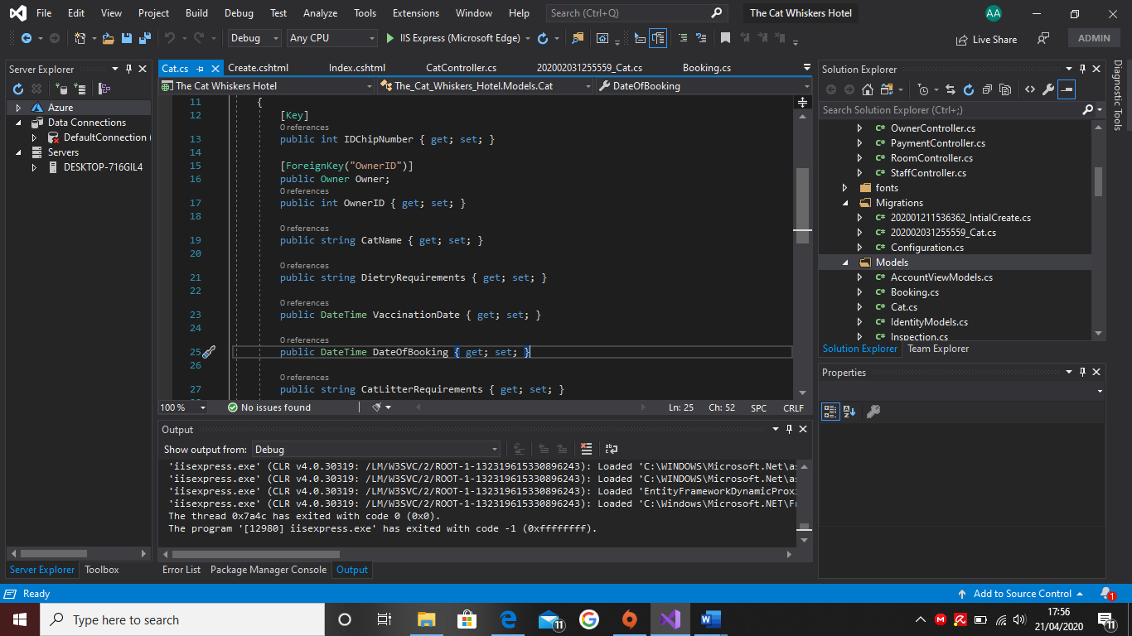
Figure 11: The Cats Controller is being shown which shows the data types

4.1.2 Issues encountered and solutions during development
The application on build had numerous issues:
Crashed during development and missing objects: the application had numerous crashes but there was a major issue when it refused to open due to a missing migration, or a database was missing. The only possible solution was to add a new migration, unfortunately, whenever the code was written the program would refuse to add a new migration due to a missing database in the end, the best course was to start again from a backup point. The screenshot below shows an error message that appeared when the program was running in Microsoft Edge. It read that the database for bookings was missing or had changed since the last migration for bookings was made. As previously stated, it was not possible to make a new migration as the program would not allow it due to a missing database.
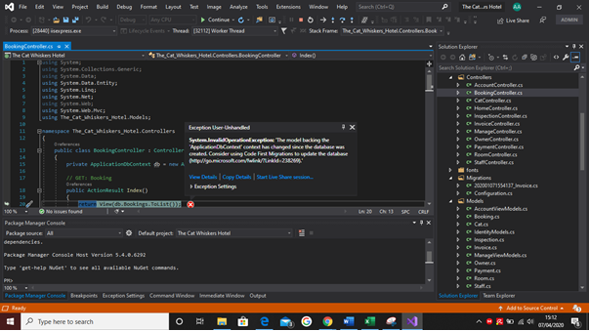
Figure 12: An error message popped up saying the database has changed and needs the migration to be updated

Pages refused to open: When the application was running in Microsoft Edge, there were issues with pages running in Edge. An example of this is when the bookings page would load up but when you went to the cat’s page, the application would crash and force close itself and show what part of the code is causing the crash to occur. The solution to this issue was to compare the codes with the other pages or to make sure that the cats controller had a migration and a model as this was easy to overlook and to make sure the codes were similar in order to open the page.

Data not being saved or appearing after being accepted: When the user is inputting data into the tables, the data would disappear as it would not save correctly due to an issue in the code disallowing it to do so. The solution to this issue is to check the other codes to see why they save or to look online for further research.

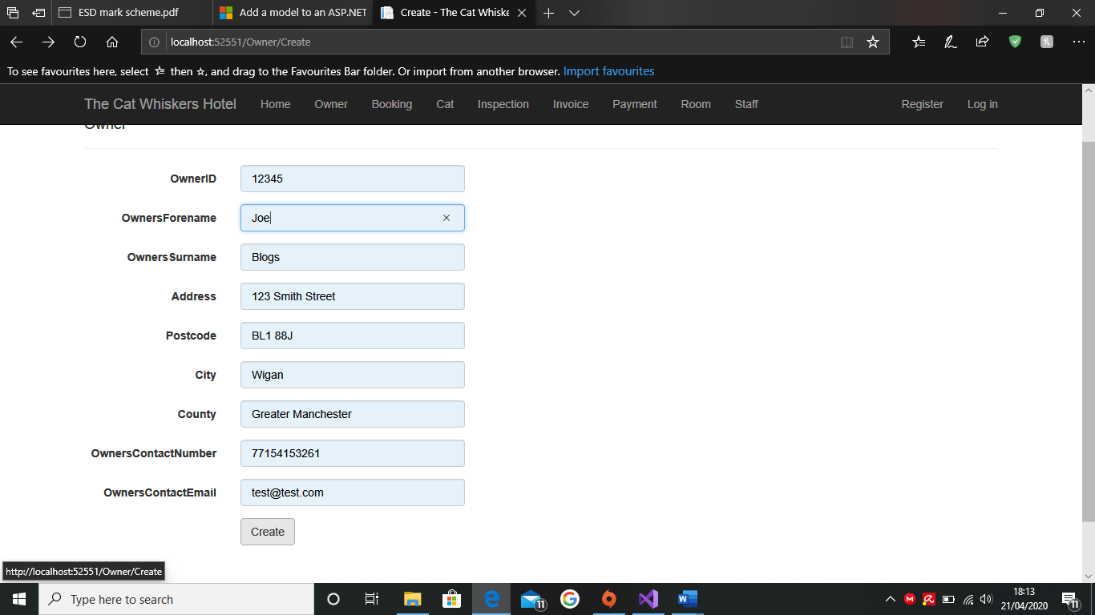
Figure 13: Data inputted for Owner

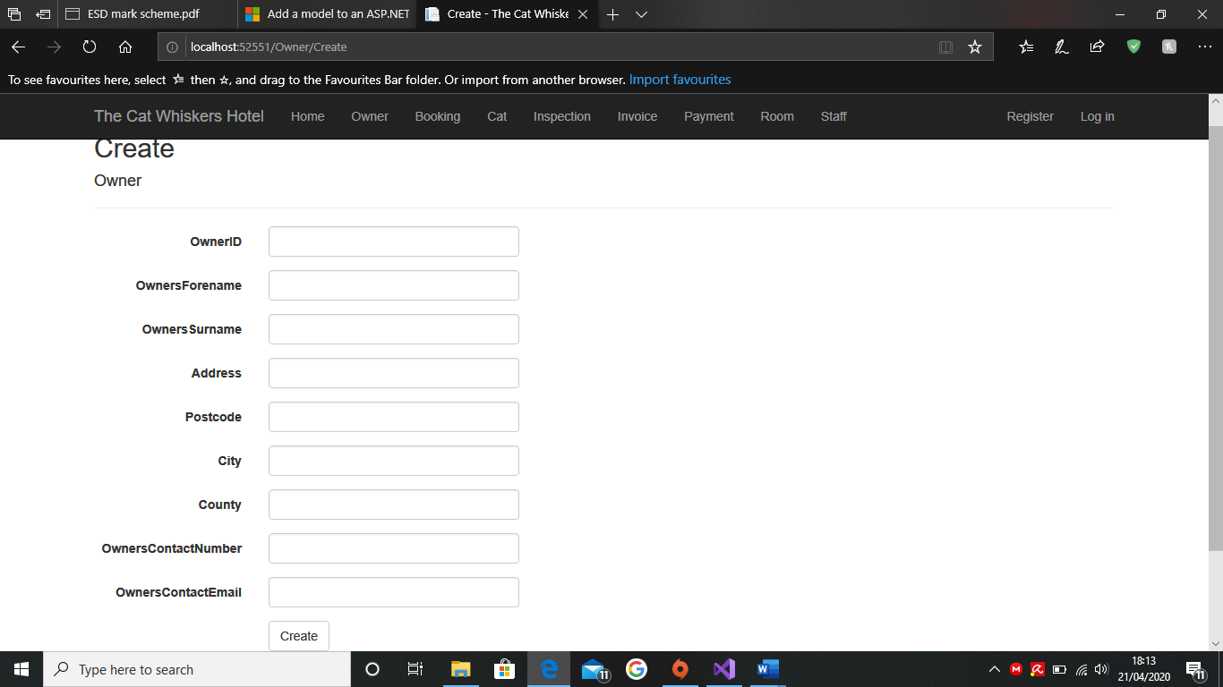
Figure 14: The data has disappeared despite the create button being pressed
No Limitations on Data Type: When you are typing data in the text boxes, there are supposed to be limitations which restrict you from going over a specific length or use characters that are incorrect in that field. The solution to this issue is to state the limitation in the code and to make sure the data type is correctly modified so no other character can be inserted. An example of this is typing a number in the name field instead of a letter, usually the program would stop and ask the user to change the field but it will instead carry on like normal.

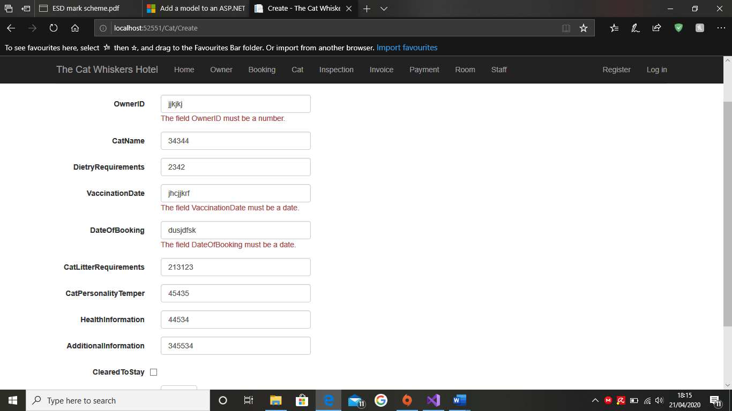
Figure 15: Warning messages to let the user know to put numbers in instead of letters
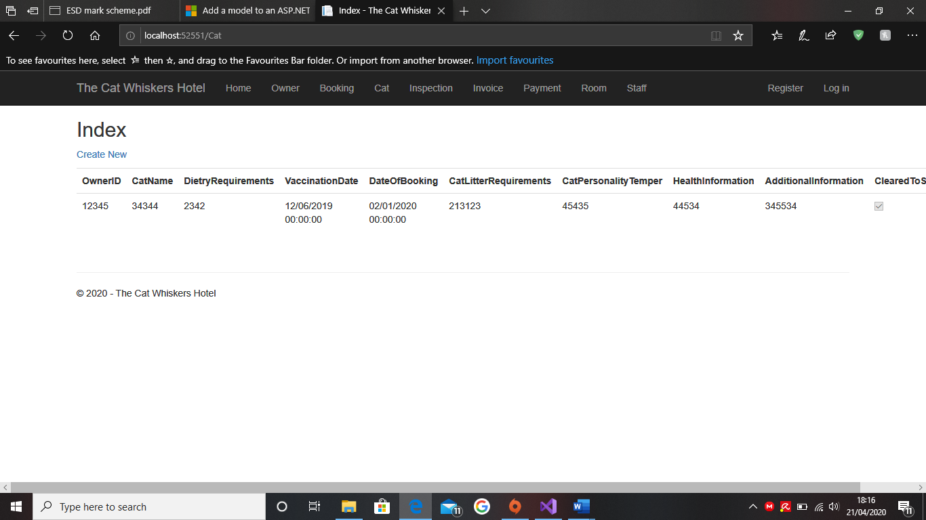
Figure 16: Despite the warning about numbers, the system allowed data to come through despite limitations being placed beforehand

4.2 A simple mobile device application and web service CCTV
Unable to build the applications within the time limit due to time constraints and issues with the main application which were extensive and caused a number of reboots.

Stage 4: Creation of documentation and testing

User Guide
Firstly you need to download the program in order to use it

You should see this below
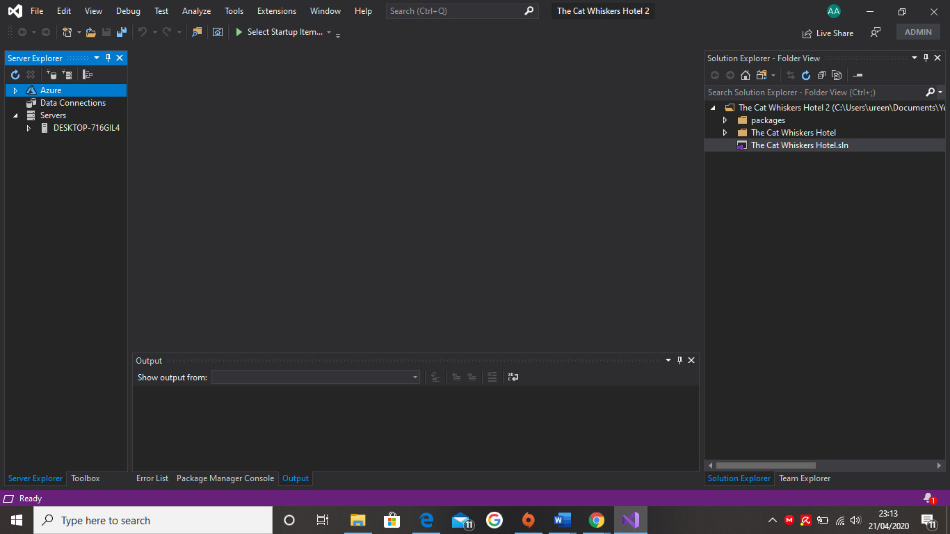
Figure 17: Visual Studios opened but not the solution

The next step is to open the solutions which is below “The Cat Whiskers Hotel” folder and then the code should appear
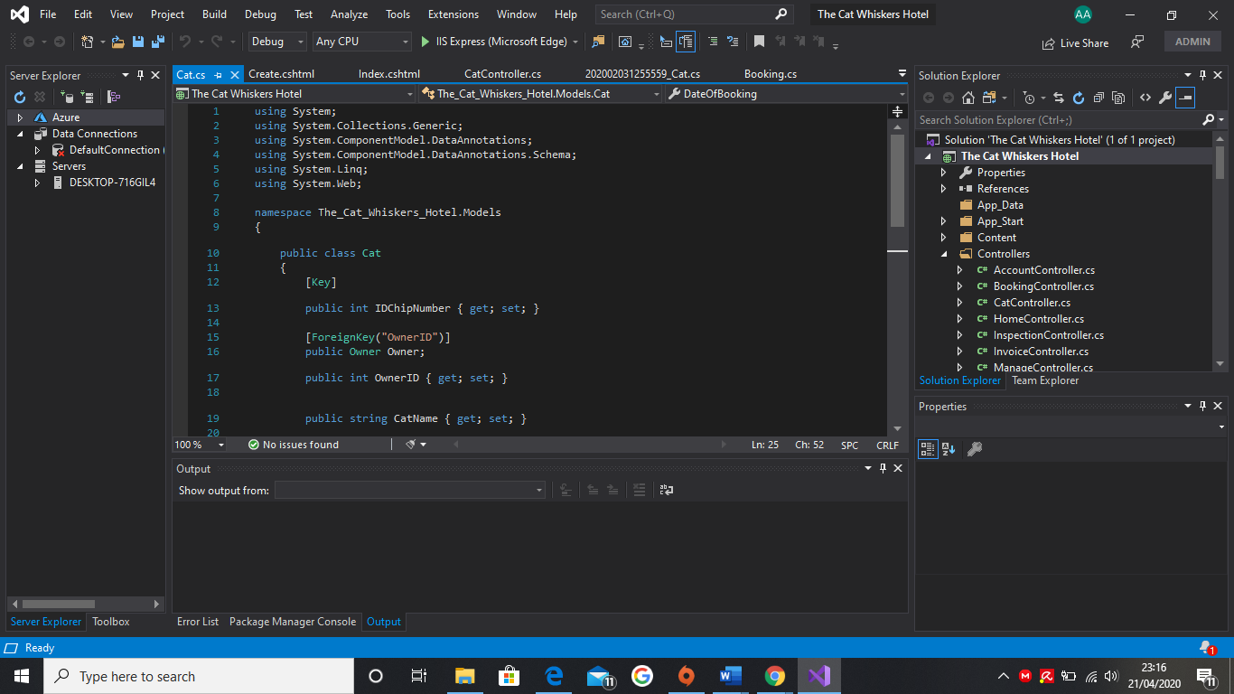
Figure 18: The solution is opened and can now be accessed through Microsoft Edge
After this appears, click on “IIS Express (Microsoft Edge)” to load the program in an internet browser. The screenshot below is what should appear
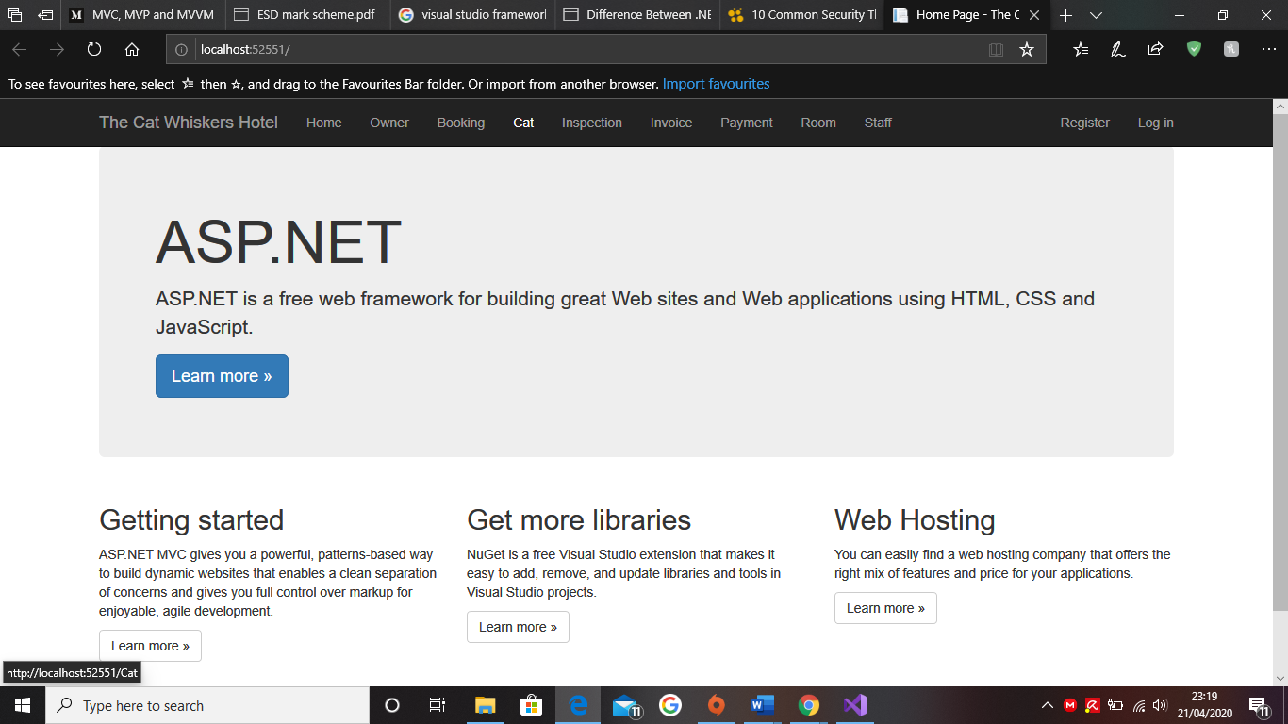
Figure 19: The homepage that appears when the application runs on Microsoft Edge
For this example we are going to click on Cats. The screenshot below is what should appear.
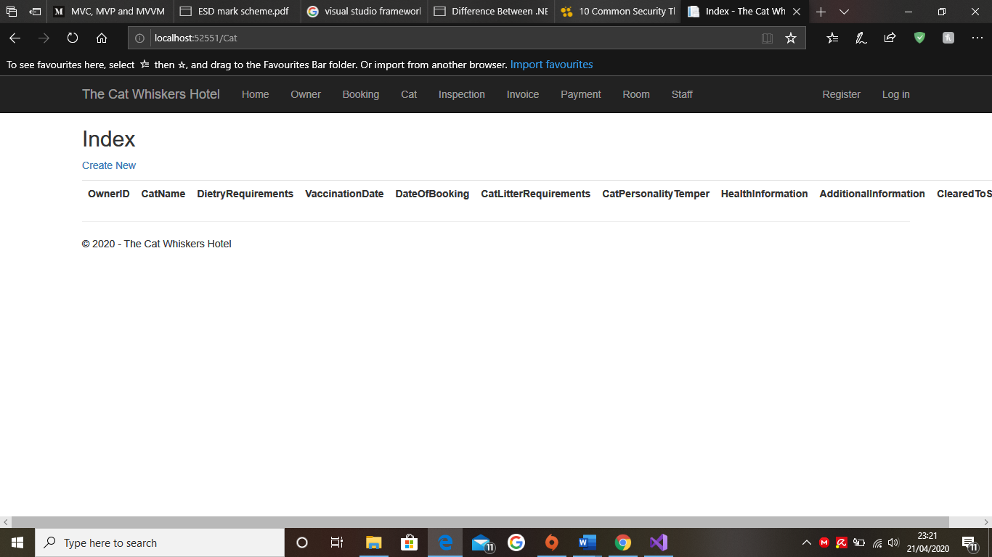
Figure 20: The Cats page is opened
If the user wants to input new data, they can create a new one by clicking create new. The below is what the user should see.
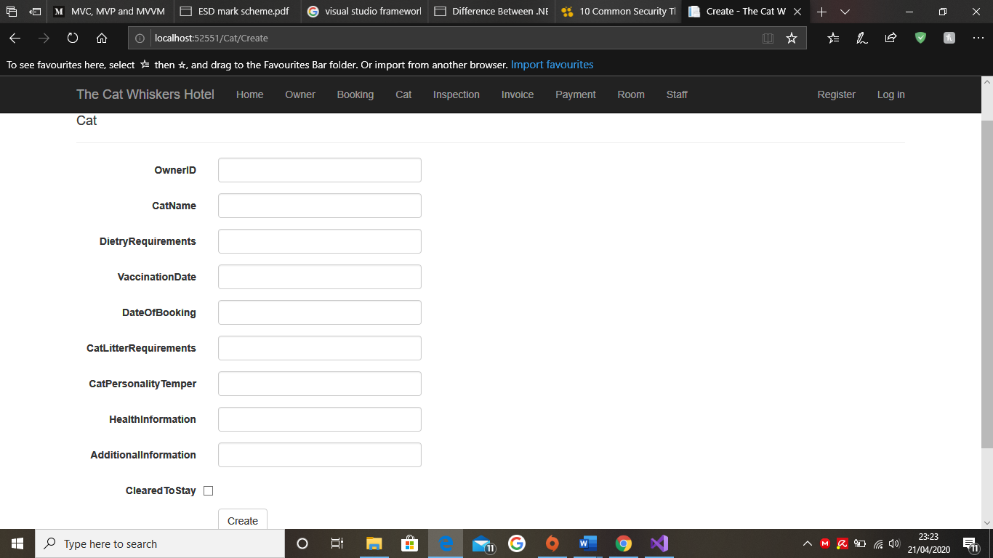
Figure 21: The Create new page for Cats but no information has been placed inside yet

Now, lets put data into the fields and click create to see what will happen.
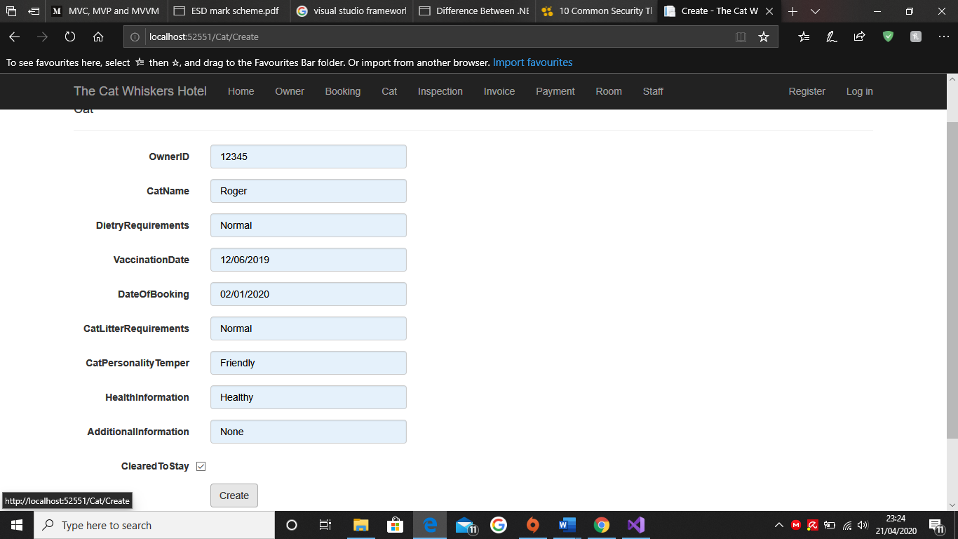
Figure 22: The Create New page for Cats with data placed inside
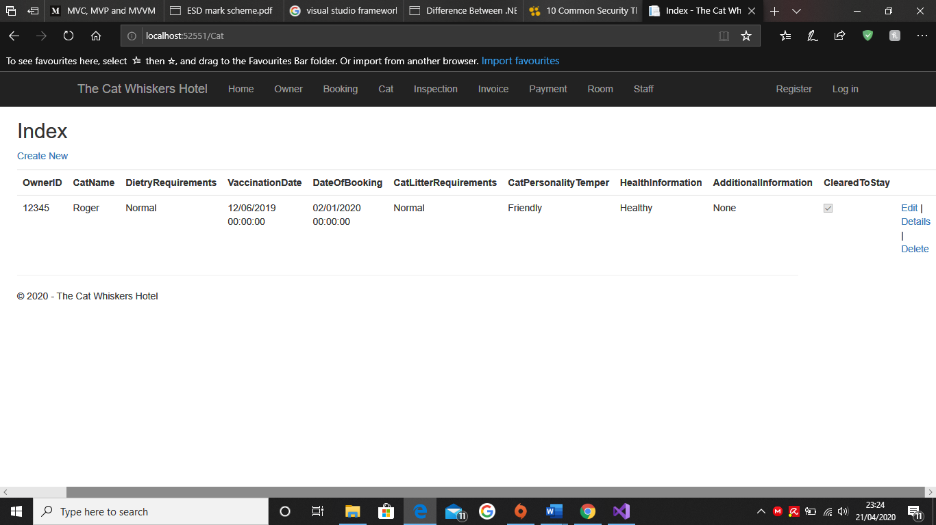
Figure 23: The Data is now showing on the Cats Page

This is what should happen when the user creates a “Cat” data and if they want to change or remove it, they can do so with the options on the right-hand side. This same method works for all tabs and should all input the data the same as “Cat” did.

White Box Testing
What happened | Justify Why | Predicted Result | Actual Result
Opened Visual Studios | Because we need to access the application through this program | Visual Studios opened | Visual Studios opened
Accessed the cat whiskers hotel application | Because this is the application, we have been working on | The application opened | The application opened
Use the cat whiskers hotel through Microsoft Edge | Because we need the application to run on an internet browser | The program opened in an internet browser | The program opened in an internet browser
Clicked on Cats | Because we need to test 2 data fields in order to see if the program works correctly or not | It went onto the cats page | It went onto the cats page
Click on create new | Because we need to see if the “Cats” can produce new data | The “create new” page opened | The “create new” page opened
Input data and create it | To see if the data can be saved or not | The data has been inputted | The data has been inputted
Clicked on Bookings | Because we need to test 2 data fields in order to see if the program works correctly or not | It went onto the Bookings page | It went onto the Bookings page
Click on create new | Because we need to see if the “Bookings” can produce new data | The “create new” page opened | The “create new” page opened
Input data and create it | To see if the data can be saved or not | The data has been inputted | The data did not input and takes you back to the create new page which caused this part of the project to fail.
Table 5: White Box Testing of the application

Evaluation
On reflection, the deliverables sounded easy to achieve on paper however, when executing they proved difficult due to a lack of information about how to approach a project of this magnitude. If the correct information had been available then potentially, I would have managed the project better. The main elements which were successful was the planning, which were both undertaken on paper and electronically. The electronic version was used in the final application, which was evidenced that the initial plan was perfect for this project.

Another successful element was the initial build, which when being built, all systems were working flawlessly, I did not experience any issues compared to my peers. In contrast, I experienced a number of issues, the first, in the development of the application involved the pages not loading correctly, this was caused by a database not working correctly and as a result it was removed completely, which caused the program to be non-responsive. Whenever a change was made, it was rejected due to the need for a migration in order to proceed and update the database following the change. However, it was not possible to undertake a migration because the database was missing, which made it difficult to proceed.

Another problem I encountered was the number of times I had to restart due to an error in the code, that neither myself nor my peers could fix. This resulted in three program restarts and pushed development time further back, as I had to put all of my attention onto the main application. This led into another problem, which was the development of the mobile application and the web CCTV program; these could not enter the development cycle due to the amount of time that was spent making the main application and addressing the issues that arose. This resulted in an unfinished project, which I could have improved with more time. In order to improve the project, I would have added a login page to the main application, so that only the client and his staff could access the system. In addition, I would also make the design more professional. Furthermore, I would improve my time management, as I ran out of time to start the other two applications which were sorely needed in this project.

If more time was available, I would have used a different framework known as .NET Core because it has a cross platform feature which would have been helpful in this project, due to the application being built on a computer system and a mobile device. Moreover, I would have tested a different design pattern instead of MVC; I would have liked to have tried MVP which has been proven better than MVC. The final change I would have made is to have used another program other than Visual Studios because I felt it was too sophisticated for me. I would have preferred an application that informed me what the issues were immediately, rather than later as it caused problems and made it difficult to fix and integrate more deeply into the system.

Conclusion
In Conclusion, considering all the difficulties I encountered, I am proud about how the project developed. Overall, I felt like I could have pushed myself to feel invested into the project and to do further research into design patterns software and framework to ensure the main application could meet the clients’ needs more closely.

References
InfoTech, A., 2019. What’s the difference Between .NET Core vs .NET Framework. [Online]
Available at: https://www.amarinfotech.com/difference-between-net-core-2-0-vs-net-framework.html
[Accessed 21 April 2020].
Sinhal, A., 2017. MVC. MVP and MVVM Design Pattern. [Online]
Available at: https://medium.com/@ankit.sinhal/mvc-mvp-and-mvvm-design-pattern-6e169567bbad
[Accessed 21 April 2020].

